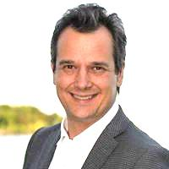

January 10, 2020

Dear Presidents, Board Members and Neighbours:

In 2019, proved to be a very busy and exciting year for all of us and I am looking forward to 2020 with energy and enthusiasm!
Over the past year, I enjoyed working with you and our local business leaders to address questions and concerns. Every Ratepayer Association, along with its members, has been outstanding in their efforts and commitment. Your dedication ensures that our neighbours and communities are second to none.
I was pleased to host Information Sessions throughout the Ward to address various issues relating to health and safety for seniors, by-law issues, wildlife matters, and a number of public meetings to inform you of future proposed developments. A major issue across the Ward is road safety and since being elected I have been an active member of the Road Safety Committee. One of the initiatives that I advocated for was speed zones to be reduced from 50k to 40k in residential areas. I’m pleased to report that additional neighbourhoods throughout Ward 1 will be implemented this year, as well.
You will find up to date information on my website and e-newsletters so I encourage you, if you are not already signed up for my e-newsletter or website to do so. I find your newsletters, social media, and websites very informative and if you are looking or in need of articles or sponsorship for your newsletters, please let me know.
Should you require any assistance in coordinating community events, hosting meetings etc., I will be happy to assist by way of a City community facility. As well please remember that my community tent is available to be loaned out for your events. Thank you again for taking such a dedicated interest in our community and I appreciate working with you on all of your community issues.
Our Community is Our Home!
Sincerely,
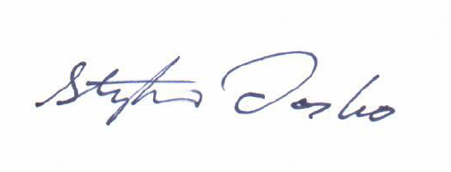
Stephen Dasko
Councillor, Ward 1

