September 21, 2020

Re: Neighbourhood Review of Zoning Regulations

Dear Resident,

We have arranged a Virtual Community Meeting for Wednesday, October 14, 2020 at 6:00 p.m. If you are unable to participate in the virtual meeting, I have enclosed a survey, which addresses the issues and encourage you to complete and send to Jordan Lee by October 28, 2020.

The virtual meeting details are as follows:
Visit: Mississauga.webex.com
Meeting #: 172 171 7825 Password: ward1
If you encounter challenges, you may call into the meeting using: (647) 484-1596
Meeting Code #: 172 171 7825
Mobile device (attendees only) +1-647-484-1596,,1721717825## CANADA Toll

In light of changes that are occurring to housing in your neighbourhood, the City of Mississauga is reviewing the zoning regulations that would apply to your property (see attached map). The implications of potential changes that could affect your property include, but are not limited to:

- Permissions for type of housing (e.g. detached dwelling, semi-detached dwelling, townhouse dwelling, etc.)
- Minimum lot size and frontage
- Required setbacks for buildings and structures
- Maximum height of dwelling

The purpose of the community meeting will be for staff to present potential options for revised zoning regulations for your property. You are welcome to provide feedback on these potential changes, and ask any questions of staff.

Should you have any questions prior to the scheduled meeting, please contact Jordan Lee, Planner at 905-615-3200 ext. 5732, or by email at jordan.lee@mississauga.ca

We hope to see you there.

Sincerely,
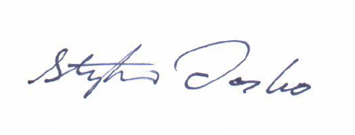
Stephen Dasko
